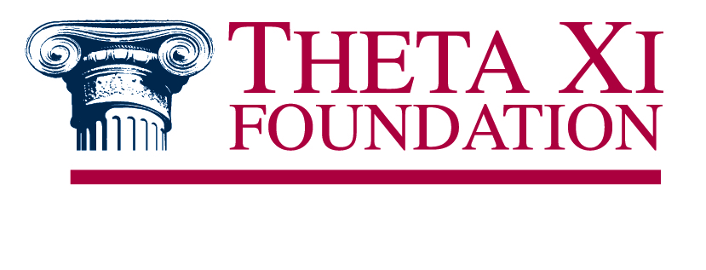

Sample Language for Wills & Bequests

General Purposes
I give and bequeath to the Theta Xi Foundation (Federal Tax ID # 43-6049500), a not-for-profit 501(c)3 organization, the sum of $_________ (or _____) to be used by the Theta Xi Foundation in fulfillment of its educational purposes as the Theta Xi Foundation Board of Trustees shall determine.
Restricted Purposes
I give and bequeath to the Theta Xi Foundation (Federal Tax ID # 43-6049500), a not-for-profit 501(c)3 organization, the sum of $_________ (or _____) to be used by the Theta Xi Foundation in fulfillment of its educational purposes as the Theta Xi Foundation Board of Trustees shall determine. I further restrict the use of these funds to support the JEV Memorial Endowment, which provides funding to ensure the continued work of the Vredenburgh Leadership Academy. Should this particular endowment fund no longer be in place at the time of my death, then the funds shall be placed in whatever other endowment fund the Trustees see fit.
Note: The italicized portion of the above statement is provided as example only. Should a donor wish to restrict their bequest to another purpose, then simply replace that language with what your desired use may be; please consult with Foundation staff should you have any questions.

Last Update: 11/12/2015

